13-1_SQL_ Trushkova_Creating_tables

**Vocabulary**

Created and maintained by the Oracle Server and contains information about the database**- Data dictionary**

A collection of objects that are the logical structures that directly refer to the data in the database- **Schema**

Specifies a preset value if a value is omitted in the INSERT statement- **DEFAULT**

Stores data; basic unit of storage composed of rows and columns- **TABLE**

Command use to make a new table- **CREATE TABLE**

**Try it/Solve it**

1. Complete the GRADUATE CANDIDATE table instance chart. Credits is a foreign-key column referencing the requirements table.
2. Write the syntax to create the grad_candidates table.

1. Confirm creation of the table using DESCRIBE.

1. Create a new table using a subquery. Name the new table your last name -- e.g., smith_table. Using a subquery, copy grad_candidates into smith_table.

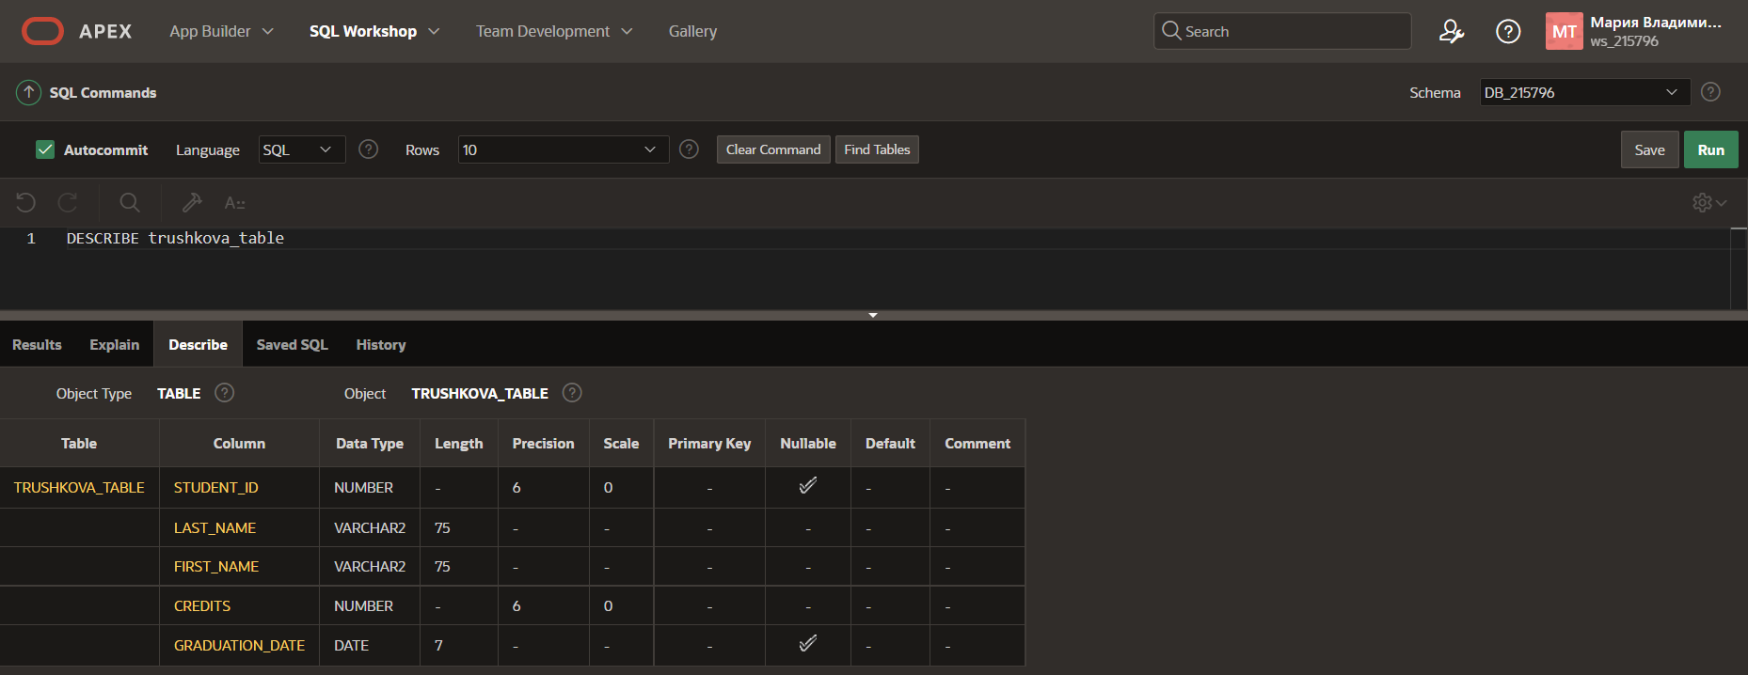

1. Insert your personal data into the table created in question 4.

1. Query the data dictionary for each of the following:

• USER_TABLES. This query shows all tables that belong to user and their status. Also it describes the relational tables owned by the current user.

• USER_OBJECTS describes all objects owned by the current user.

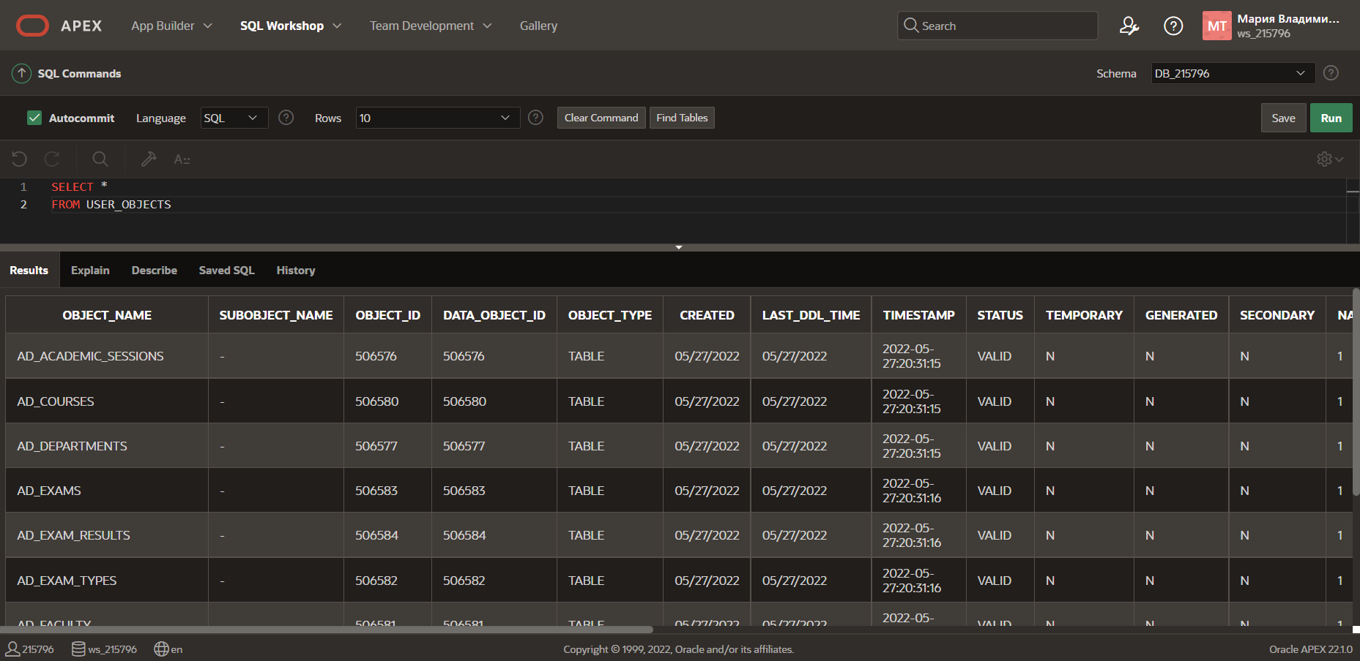

• USER_CATALOG or USER_CAT shows all objects which belong to user and their type

